Below sections summarize the steps taken to complete DAND’s Project 0: Exploring Weather Trends

**Extract the Data:**

* The closest big city I live next to is Riyadh, Saudi Arabia. The following SQL lines of code were used to see if Riyadh is part of the dataset:

/* Identifying available cities within Saudi Arabia*/

SELECT *

FROM city_list WHERE country = 'Saudi Arabia'

Riyadh happens to be part of the weather dataset.

* Riyadh data were extracted and downloaded using the following lines of code:

/* Extracting Riyadh Data*/

SELECT *

FROM city_data WHERE city = 'Riyadh'

* The global data were extracted using the following:

/* Extracting global Data*/

SELECT *

FROM global_data

**Open up the CVS:**

MS Excel has been used for this project for calculation and plots generation purposes.

**Create a Line Chart:**

A moving average of window-size of 10 has been used to smooth out the global and my city, Riyadh, average temperatures.

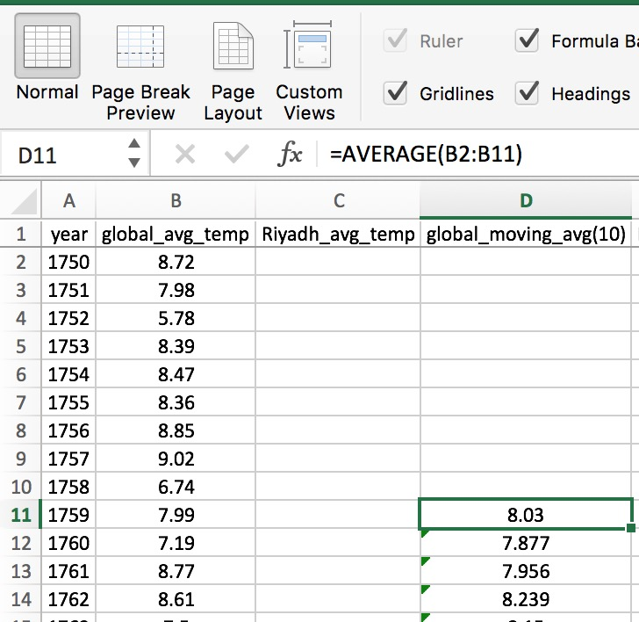

**Make Observations:**

* Riyadh has always had a higher average temperature than the global average. Riyadh average temperature is hotter than the global average by 16.85 $℃$
* Starting from 1855, Riyadh temperature profile has been incrementally increasing following the world average temperature pattern
* Starting from the 1900, the global average temperature is getting higher with time
* In 2013, Riyadh reached a record high in its average temperature of 27.78 $℃$